Myco Vera Mushrooms Business Plan
  - 250 kg per week and 500 kg per week
We propose an owner-managed gourmet mushroom farm on land already acquired in the Western Cape. We seek R460,000 for the construction and equipment target budget under either production option. The proposed harvest mix is 70% oyster, 20% king oyster and 10% shimeji. No contingency or working capital is included in the funding request.
Start with 250 kg/week and expand after yields, buyers and autoclave throughput are proven. The 500 kg/week option has better modelled margins, but one 900 L autoclave remains an unverified production constraint.
At stable production | 250 kg/week | 500 kg/week
Harvest per average month | 1,083 kg | 2,167 kg
Mushrooms sold after 5% loss | 1,029 kg | 2,058 kg
Monthly mushroom sales | R132,968 | R265,937
Monthly cash surplus | R62,945 | R154,333
Indicative funding envelope | R460,000 | R460,000

Cash surplus includes owner remuneration, R5,000/month for hired assistance, expected rent, the mortgage and rates. It is before income tax, new finance repayments and further capital spending. The revised costs are target allowances requiring supplier quotations and production trials.
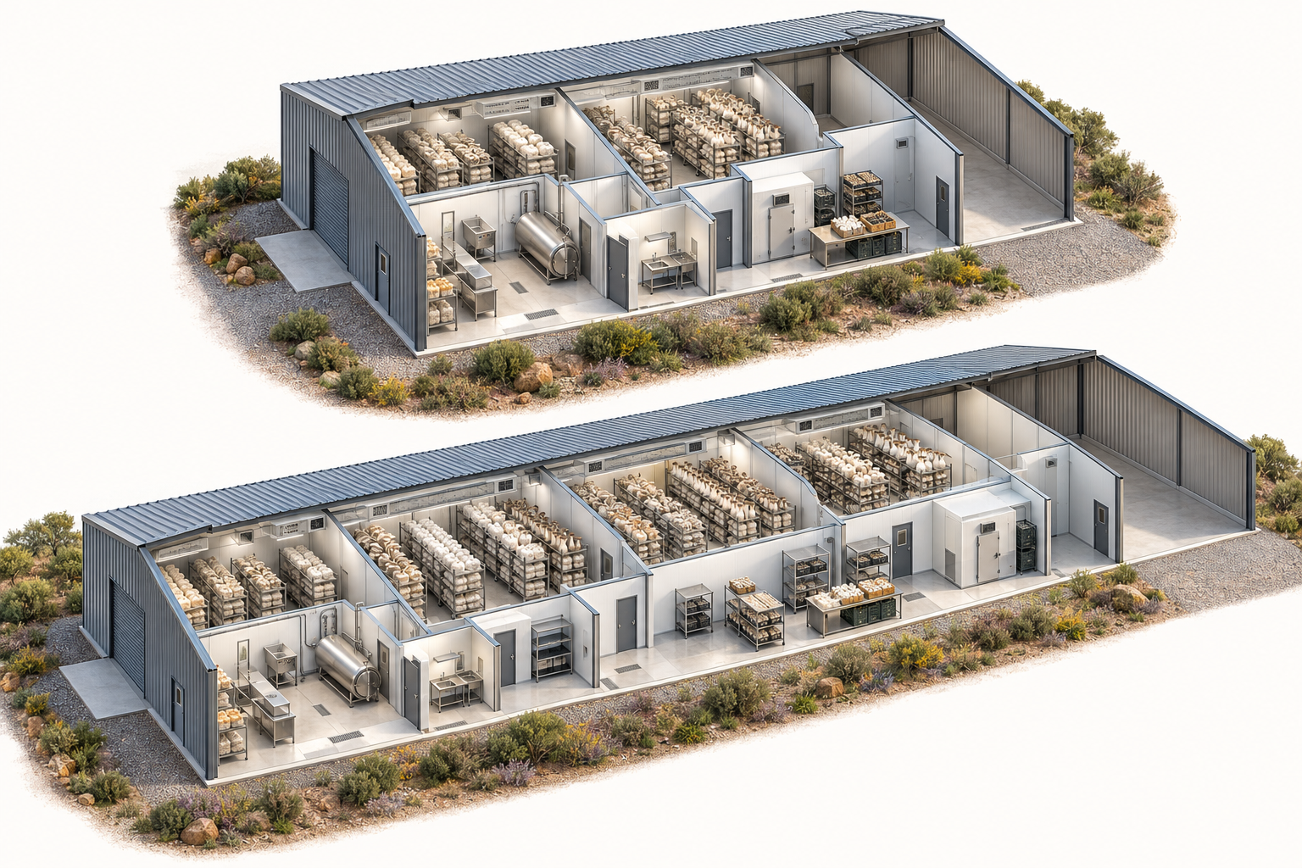
Upper concept: 250 kg/week. Lower concept: 500 kg/week. Artist impressions only; room counts and dimensions are defined by the tables, not the pictures.
Read pages 1 to 4 for the proposal. Pages 5 to 11 provide the evidence and calculations.
PROPOSAL | 2 OF 4

Land and infrastructure

Land and additional income
The land is already acquired. The original mortgage was R700,000; the confirmed repayment is R7,300/month, with rates and taxes of R1,300/month. The outstanding balance and current equity have not been established. No new land purchase is included.
A separate tenant is expected to pay R5,000/month. We budget R4,750 after a 5% vacancy allowance, with no rental maintenance reserve. The net property burden is therefore R3,850/month. Rent is forecast, not contracted. Tenant utilities are assumed separately paid; residential completion costs are outside this farm request.
Space allowance | 250 kg/week | 500 kg/week
Fruiting rooms | 4 × 24 m² = 96 m² | 8 × 24 m² = 192 m²
Incubation including shimeji | 60 m² | 120 m²
Preparation and clean inoculation | 24 + 10 m² | 36 + 14 m²
Packing and cold storage | 12 + 6 m² | 20 + 10 m²
Staff facilities and service access | 12 + 40 m² | 16 + 52 m²
Reserved empty shell bay | 40 m² | 60 m²
Total shed allowance | 300 m² | 520 m²

Materials and construction
Use a steel shed over an engineered concrete slab. Inside it, build sealed rooms from 75–100 mm PIR insulated panels with washable coated metal skins. Specify suitable fire performance, supported ceilings and sealed penetrations. Fit insulated doors, protected panel bases, coved floor junctions and a durable wet-area floor finish. [6]
Form approximately 1–2% floor falls to accessible trapped drains, subject to the drainage design. Keep wet preparation separate from clean inoculation. Each fruiting zone needs its own temperature, humidity and CO₂ control, distributed air supply and outdoor exhaust; avoid sharing untreated return air between rooms.
Typical module: 6 × 4 m internal, about 2.7 m high, four rack tiers. Panel thickness is additional. Use removable galvanised racks with coating-compatible cleaning, or stainless steel in the most corrosive areas. See the room diagram on page 8. Detailed setting-out remains to be designed.
PROPOSAL | 3 OF 4

Sales and business running costs

Possible sales avenues
Target restaurants, hotels, independent grocers and produce distributors for 80% of volume, with 20% sold directly through preorders and markets. Approach specialist Cape Town suppliers such as Funki Fungi and Yeoman as prospective partners, not confirmed buyers. Supermarket supply is a later channel, conditional on audits, consistency and buying terms. [2, 13]
The estimated blended selling price is R129.20/kg received on sold product. It uses farm prices below observed retail prices. Customer delivery, packaging and selling costs are budgeted below; price details appear on page 5.
Monthly cash budget | 250 kg/week | 500 kg/week
Mushroom sales | R132,968 | R265,937
Expected rent after vacancy | R4,750 | R4,750
Substrate spawn and filter bags | R7,368 | R14,737
Sales packaging | R8,233 | R16,467
Electricity | R20,971 | R35,250
Hired staff | R5,000 | R5,000
Owner remuneration | R15,000 | R20,000
Delivery and selling | R6,000 | R10,500
Water waste hygiene and testing | R3,600 | R5,800
Mortgage payment | R7,300 | R7,300
Rates and taxes | R1,300 | R1,300
Total cash outflows | R74,773 | R116,354
Cash surplus before tax and new finance | R62,945 | R154,333

The owner will work in the business. Both options allow R5,000/month for hired assistance; hours and employment arrangements must be confirmed. No fixed number of full-time employee posts is assumed within this allowance. Substrate, spawn and filter bags are budgeted at one-fifth of their previous combined cost, an 80% reduction.

Other income opportunities
Spent substrate for composting, grow kits and training may add income after the production system is established. No sales from these activities, grants or solar exports are included in operating revenue. Do not double-count mushrooms diverted into other products.
PROPOSAL | 4 OF 4

Funding request and delivery plan
We seek grant funding, equipment sponsorship or patient investment of R460,000 for a staged build. Both production options use the same revised construction and equipment target budget. They are alternatives and must not be added together. Any owner cash or equipment already paid for will reduce the final request.
Use of funds | 250 kg/week | 500 kg/week
Construction and equipment | R460,000 | R460,000
Total indicative requirement | R460,000 | R460,000

The funding request excludes contingency and working capital. Neither mortgage settlement nor residential construction is requested. Land access is the owner contribution; a valuation and current bond statement are needed before assigning an equity value. Startup operating cash requirements are shown separately on page 10 and are not included in the request.

Delivery milestones
Stage | Evidence required before progressing
Design and sales validation | Confirm land use, services, three supplier quotes and buyer terms. Obtain letters of intent covering at least 70% of forecast sales.
Build and commission | Complete shed, hygienic rooms, cold chain and utilities. Validate autoclave loading, cycle records and climate controls.
Commercial launch | Start oyster and king oyster batches; keep shimeji at trial scale until its full cycle is proven. Build a stable weekly order book.
Expansion decision | Consider 500 kg/week after three consecutive months of positive cash flow and acceptable losses, with additional buyer demand and proven sterilisation capacity.

Employment and funding case
The owner will lead production, with R5,000/month allocated to hired assistance. Track kilograms sold, paid hours of assistance, training completed, substrate reused and electricity per kilogram. Additional employment can be considered as sales and production are established; no two-job or four-job commitment is included in this revised budget.
Western Cape CASP is a relevant route to discuss with an extension officer. The published 2027/28 application deadline was 15 May 2026, so this plan does not treat that round as open. Corporate equipment sponsorship and private investment can be pursued in parallel. Eligibility and asset ownership terms require confirmation. [10]

Conditions that matter to a funder
The revised target costs produce positive modelled cash surpluses in both options. The larger option depends on selling about 475 kg/week and proving one autoclave can support the workload. Obtain the food-premises Certificate of Acceptability, site approvals and supplier compliance documentation before commissioning. [11]
For an investor, title, the operating entity, the lease or right of use, rent entitlement and ownership of funded improvements must be documented. This is a pre-feasibility proposal for discussion; quotations, trials and buyer commitments are still required.
APPENDIX A | SUPPORTING DETAIL

Price evidence and sales assumptions
Public asking prices checked on 3 October 2026 provide market context. Retail prices include the retailer’s costs and margin and are not farm-gate offers. Location, availability, promotions and delivery charges can change the realised price.
Product | Public benchmark | Equivalent per kg
Blue oyster | Woolworths 250 g at R69.99 [1] | R279.96
King oyster | Woolworths 150 g at R38.99 [1] | R259.93
Shimeji | Woolworths 150 g at R38.99 [1] | R259.93
Oyster | Funki Fungi public order price [2] | R160
King oyster | Funki Fungi public order price [2] | R192
Shimeji | Funki Fungi public order price [2] | R180

Public food-service prices are not farm-gate offers. MYCO-FEEDS supplies fresh wholesale mushrooms by quotation; its R190/kg listing is spawn. No reliable negotiated wholesale price was established. [2, 3]

Estimated selling prices used in this plan
Product | Harvest mix | Bulk estimate | Direct estimate | Blended price
Oyster | 70% | R110/kg | R160/kg | R120/kg
King oyster | 20% | R145/kg | R190/kg | R154/kg
Shimeji | 10% | R135/kg | R180/kg | R144/kg
Weighted total | 100% | R119.50/kg | R168/kg | R129.20/kg

These farm prices are estimates, not wholesale quotations. The blend assumes 80% bulk and 20% direct sales for each species. Confirm actual buying terms before investment.

How much must be sold
Weekly sales target after 5% loss | 250 kg/week | 500 kg/week
Total sold | 237.5 kg | 475 kg
Bulk and food service at 80% | 190 kg | 380 kg
Direct customers at 20% | 47.5 kg | 95 kg
Illustrative bulk order book | 19 accounts × 10 kg | 38 accounts × 10 kg
Direct equivalent at 250 g packs | 190 packs | 380 packs

These are prospective account numbers. Confirm samples, delivery, payment and returns terms. Startup cash collection allows one month after sale. Retailer listing and promotion fees require a separate margin calculation.

VAT and accounting basis
Costs are cash allowances in 2026 rand, including VAT where charged, without assuming input-VAT refunds. Fresh mushrooms are treated as zero-rated vegetables for registered vendors. The full mortgage repayment is included in cash outflows, not claimed as a deductible expense. Confirm entity accounts and tax treatment with an accountant. [12]
APPENDIX B | ASSUMPTIONS TO TEST

Production capacity and room loading
Targets mean saleable-quality harvested mushrooms before a further 5% unsold or post-harvest loss. Allow 8% failed blocks before harvest. Yields below are assumptions per successful block, not trial results or supplier guarantees. Shimeji means cultivated beech mushroom, Hypsizygus marmoreus.
Parameter | Oyster | King oyster | Shimeji
Wet block before spawn | 3.0 kg | 2.5 kg | 1.4 kg
Dry matter fraction | 38% | 38% | 40%
Harvest per successful block | 0.75 kg | 0.50 kg | 0.35 kg
Biological efficiency on dry base | 66% | 53% | 63%
Incubation and maturation | 3 weeks | 5 weeks | 16 weeks
Fruiting and turnover allowance | 3 weeks | 4 weeks | 5 weeks
Blocks started weekly at 250 kg | 254 | 109 | 78
Blocks started weekly at 500 kg | 508 | 218 | 156

Research reports 110 days of maturation in a tested shimeji system and 140–150-day harvest periods for the strains studied. The 16-week incubation allowance reflects that longer cycle; local cultures must be tested. The other crop schedules are provisional and may also lengthen. [5]
Calculated inventory | 250 kg/week | 500 kg/week
Blocks started each week | 441 | 882
Wet substrate each week | 1,144 kg | 2,287 kg
Dry ingredients each week | 437 kg | 874 kg
Incubating block positions | 2,555 | 5,110
Fruiting block positions | 1,588 | 3,176
Approximate substrate in all rooms | 9.3 tonnes | 18.6 tonnes

Room allocation
For 250 kg/week, allow two oyster rooms, one king oyster room and one shimeji room; double these at 500 kg/week. Divide the king and shimeji modules into independently controlled batch bays where feasible. The final schedule must permit empty-room cleaning; uninterrupted weekly shimeji harvests cannot yet be guaranteed.
One 24 m² room has 34.56 m² of rack surface: two racks × 4.8 m × 0.9 m × four tiers. At an assumed 14 block positions/m² of shelf, it holds about 484 blocks. At 250 kg/week, oyster needs 762 positions, king 436 and shimeji 390. Fit and airflow must be proven with full-size blocks and fruitbodies.
Incubation needs at least 3,066 positions including 20% spare capacity, or 6,132 at the larger scale. The 60/120 m² allowance assumes roughly 55% rack footprint and five tiers, but requires a detailed rack and heat-removal design. Saturated block weights, rack loads and slab capacity must be checked before construction.
APPENDIX C | QUOTATION SCHEDULE

Construction and equipment budget
Both options use the same R460,000 construction and equipment target budget for a new building and the proposed equipment. These amounts are procurement targets, not contractor or supplier quotations. Installed room envelopes include walls, ceilings, trims and doors; refrigeration is separate. No solar array or new vehicle is included.
Item | 250 kg/week | 500 kg/week
Shed and structural slab | R150,000 | R150,000
Insulated room envelopes and doors | R150,000 | R150,000
Climate control and cold refrigeration | R50,000 | R50,000
Racking and handling | R50,000 | R50,000
900 L autoclave | R50,000 | R50,000
Preparation and clean room equipment | R10,000 | R10,000
Capital subtotal | R460,000 | R460,000
Total funding envelope | R460,000 | R460,000

Basis of the revised budget
The shed and structural slab allowance is R150,000 in each option. Insulated room envelopes and doors are also R150,000 in each option. The proposed 300/520 m² layouts remain conceptual; the common budget does not establish that both sizes can be delivered for the same price.
Climate control and cold refrigeration, racking and handling, and the 900 L autoclave each have a R50,000 allowance. Preparation and clean room equipment has a R10,000 allowance. Confirm supplier scope, usable capacity and installation requirements against these targets.
The R50,000 autoclave allowance is a revised procurement target, not a verified 900 L supplier price. The electricity and throughput model still assumes one 900 L, 24 kW unit for each option. Obtain its datasheet, delivered quotation and pressure-equipment documentation before selection.
No separate allowance is included for wet area floors and drainage, site services and electrical connection, essential load backup, design approvals and commissioning, contingency or working capital. These excluded items do not increase the R460,000 funding envelope.
Obtain written building and equipment quotations against the six retained budget lines before fixing a formal application. If quotations or the final scope change, revise the funding request and cash flow explicitly.
APPENDIX D | CONCEPT FOR SUPPLIER DISCUSSION

Grow room construction detail
Use the following module as a starting point for quotations. Dimensions are internal clear dimensions; wall thickness, structural posts and service access require additional space. The plan is conceptual and must be checked against actual block sizes, crop clearance and rack loading.
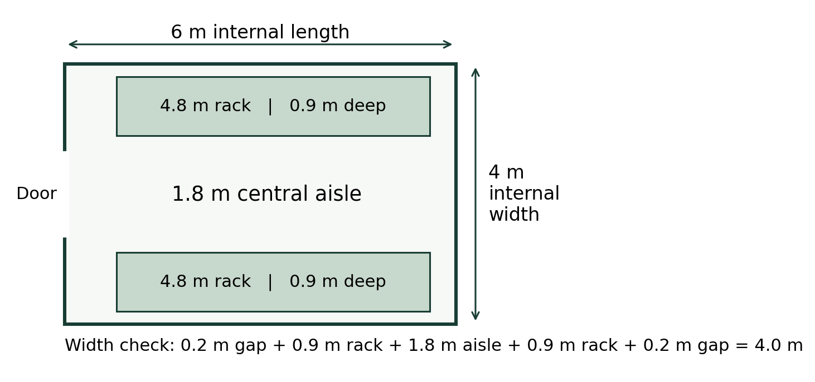
Element | Proposed material or detail
Primary structure | Engineered slab and weatherproof steel shed; chamber ceilings have their own approved supports.
Walls and ceiling | 75–100 mm PIR panels with washable coated skins, compatible sealant and sealed service sleeves. PIR is not non-combustible; approve the panel fire system with the designer. [6]
Wall base and floor | Slab damp-proofing, protected sealed base channel, waterproof coved junction and slip-resistant epoxy or polyurethane floor system suited to wet cleaning.
Drainage | Designed floor falls, trapped accessible drains and removable strainers; keep substrate solids out of drains. Verify the authorised wastewater route.
Racks and doors | Removable galvanised or stainless racks; approximately 0.2 m wall gaps. Insulated door with a practical trolley opening and accessible threshold.
Services | Washdown-compatible lights and fittings, externally serviceable fans, distributed air supply, sensors and controlled fogging. Keep condensate off the crop.

Purchase criteria should include cleanability, corrosion resistance, documented insulation/fire performance and spare-part access. Domestic split air conditioners alone do not establish adequate fresh air, humidity or CO₂ control. Final equipment selection needs a biological and ambient heat-load calculation.
APPENDIX E | REBUILT FOR WEEKLY OUTPUT

Electricity and sterilisation
Both options assume one 900 L, 24 kW three-phase electric autoclave. Nominal chamber volume does not establish its usable substrate load. The base model assumes 250 kg wet substrate per validated cycle; all species are sterilised through it.
Operating assumption | 250 kg/week | 500 kg/week
Cycles per week at 250 kg usable load | 5 | 10
Autoclave energy at 90 kWh/cycle | 1,950 kWh/month | 3,900 kWh/month
Cooling ventilation and other loads | 2,550 kWh/month | 4,600 kWh/month
Total electricity budget | 4,500 kWh/month | 8,500 kWh/month
Illustrative Eskom bill | R20,971 | R35,250
Electricity per sold kg | R20.38 | R17.13

Tariff basis
Eskom 2026/27 Landrate 2 provides a 50 kVA three-phase category. VAT-inclusive variable charges are R2.7934 energy + R0.7712 network demand + R0.0052 ancillary = R3.5698/kWh. Fixed charges are R121.31 + R30.65 + R9.37 = R161.33/day. [4]
Monthly bill = kWh × R3.5698 + R161.33 × 365/12. This uses an annual-average month, not 30 days. The tariff is illustrative until Eskom confirms the actual site supply and account category. A licensed designer must confirm peak demand; a 50 kVA connection is not a verified design for either site.

The larger facility depends on the load test
Usable substrate per cycle | 250 kg/week | 500 kg/week
200 kg | 6 cycles/week | 12 cycles/week
250 kg base | 5 cycles/week | 10 cycles/week
350 kg | 4 cycles/week | 7 cycles/week

At 6–10 hours of vessel occupancy per cycle, the base case requires 30–50 or 60–100 vessel-hours/week, including turnaround. The larger option may need extended shifts, different carts/cooling arrangements, purchased blocks or additional sterilisation equipment. None of those alternatives is assumed free; re-cost before committing.
Measure loading mass, coldest-block temperature, cycle duration and kWh. A 90 kWh cycle is only an estimate. At 60–120 kWh/cycle, total monthly energy becomes 3,850–5,150 kWh or 7,200–9,800 kWh, holding all other loads constant.

Solar is a separate investment decision
The base plan gives no credit for solar savings. Eskom requires a time-of-use tariff for grid-tied generation. Reprice the connection, model hourly self-consumption and obtain PV quotes before adding solar. Earlier batteryless solar import estimates for the 500 kg/month pilot do not apply to these facilities. [4]
APPENDIX F | FINANCIAL CHECKS

Sensitivity and startup cash
Monthly cash surplus | 250 kg/week | 500 kg/week
Downside | R13,870 | R56,183
Base | R62,945 | R154,333
Upside | R88,967 | R206,376
Minimum sold at base price and full production | 510 kg/month | 785 kg/month
Break-even price at base sales volume | R68.04/kg | R54.22/kg

Downside: 80% of target harvest, 90% sold and R105/kg. Upside: target harvest, 98% sold and R150/kg. Production costs stay at the full planned level in both tests; only sales packaging varies. These are stress tests, not probability forecasts.

Cost assumptions and exposure
The combined substrate, spawn and filter-bag budget is 20% of the previous calculated allowance: R7,368.45/month at 250 kg/week and R14,736.90/month at 500 kg/week. This is an 80% reduction in cost, with production quantities unchanged. It is a target allowance, not verified component pricing. Sales packaging remains R8/kg sold.
A 20% electricity increase reduces the base monthly surplus by R4,194 / R7,050, to approximately R58,751 / R147,283. No tenant reduces it by R4,750, to approximately R58,195 / R149,583. Maintenance, insurance, admin, marketing and the rental maintenance reserve have no allowance in this revised model.

Startup cash requirement
The model starts when production costs begin, after construction. Sales ramp as follows: months 1–2 at 0%; month 3 at 25%; month 4 at 45%; month 5 at 65%; month 6 at 80%; month 7 at 90%; months 8–12 at 100%. Allow one month to collect sales. For prudence, all monthly operating costs are held at the full-output budget throughout; expected rent starts in month 1.
Startup and annual comparison | 250 kg/week | 500 kg/week
Year 1 mushroom sales | R1,070,395 | R2,140,790
Peak cumulative operating cash deficit | R257,037 | R379,932
Startup cash provision in funding request | R0 | R0
Year 1 net operating cash movement | R97,151 | R535,606
Year 2 sales at stable volume | R1,595,620 | R3,191,240
Year 2 cash surplus at stable volume | R755,344 | R1,851,992

Year 2 uses unchanged 2026 prices and the revised target costs; it is not an inflation forecast. Capital spending is funded separately. No working capital is provided in the R460,000 request. Under the stated ramp and collection assumptions, operating cash deficits peak at R257,037 / R379,932 before recovery. A source for this cash must be established before launch; it is not an additional amount included in the funding envelope.
Core arithmetic: average month = 52/12 weeks; blocks = round up [weekly harvest share ÷ yield ÷ 0.92]; sold kg = weekly target × 52/12 × 0.95; sales = sold kg × R129.20; cash surplus = sales + R4,750 rent − all cash outflows. Detailed figures are calculated before rounding.
REFERENCES | CHECKED 3 OCTOBER 2026

Sources and application evidence
Public sources support the observed prices, tariff and selected technical points. Market evidence was checked on 3 October 2026; the target cost budget was revised on 7 October 2026. Construction prices, crop yields, market uptake and operating allowances remain planning assumptions unless explicitly identified as an observed listing. Earlier Drive-book summaries were supplied as context; those books were not independently re-extracted for this plan.
1 Woolworths Mushroom listings and pack prices
2 Funki Fungi Cape Town public order prices and food service
3 MYCO FEEDS Wholesale by quotation and spawn price
4 Eskom 2026 to 2027 Standard Prices page 43 Landrate
5 Lin and colleagues 2023 Shimeji maturation and cultivation trials
6 Isowall PIR panel thermal properties and span guidance
7 CES 4000 by 5000 by 2400 mm 75 mm panel kit
8 Afrimart 900 L autoclave listing specification discrepancy
9 Department of Employment and Labour 2026 minimum wage
10 Western Cape Agriculture CASP 2027 to 2028 deadline notice
11 City of Cape Town Certificate of Acceptability application
12 SARS VAT News 3 mushrooms treated as vegetables
13 Yeoman Group Fresh mushroom supply and product formats

Documents to add before a formal submission
Confirm the registered applicant name, CIPC documents, tax compliance and bank details; attach the owner’s CV, title or land-use agreement, current mortgage statement and site plan. Obtain a legal basis for including rental cash in the venture. Do not describe the full land value as unencumbered owner equity.
Attach written equipment and building quotations, a utility connection offer, relevant permissions, crop trial records and buyer letters stating quantities, prices and payment periods. Document the owner’s cash contribution and any equipment already owned. Revise the funding request and cash flow when these are known.
Generated concept images were created for this proposal. They replace the unavailable earlier pictures and contain no engineering quantities. The rack diagram is a calculated concept, not a construction drawing.

